Unit Name: U1 Coding with Python Lesson 2 - Project
Assessment Name: Rajeeve Abraham
Tutor/Assessor Name:
Date: 21-08-2026
How to use this document…
The reference column is to be used for the assessment question number/AC, or just to label your screenshots.
Paste your screenshot into the screenshot column.
Ensure each screenshot has an annotation to…
- Offer clarity - draw attention to specific elements in a screenshot i.e. what are you showing us?
- Provide emphasis – point out the important parts of the screenshot i.e. showing that you have undertaken something specific.
- Give context – for contextual information that explains the purpose or highlights specific areas.
Reference | Screenshot | Annotation
 | 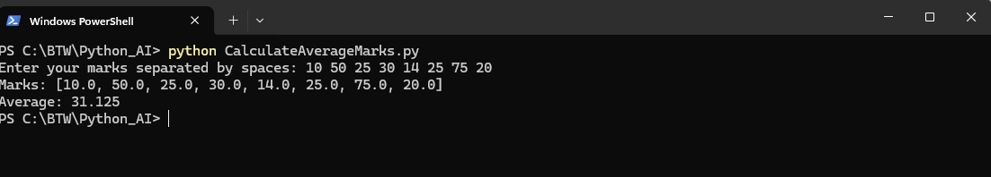 | Calculating average this is to demo built in functions
 | 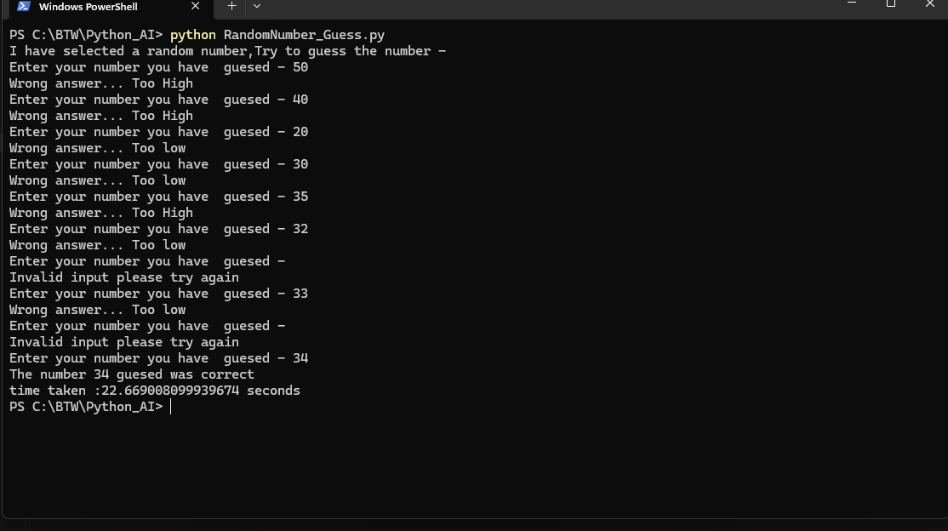 | Random number guess game

